Assessing the impact of Indian Government’s Response to COVID-19 Pandemic: Empirical Evidence to combat the Omicron-variant in India

Suhaib A.

**Abstract:**

**Background:** In may 2021, India met with its largest “Second wave” with cases peaking around 450k each day. The Second Wave was deadly as the rate and proportion of deaths were excessively rising. Furthermore there was shortage of hospital beds & oxygen cylinders and the government was unprepared for the crisis. Therefore, the need for analyzing Government response to COVID-19 arises.

**Results:** The major finding in this study is that the policy measures adopted by the Government of India are initially effective in fighting COVID-19 epidemic. However, through our time-varying approach we have identified many policy indicators to be ineffective over a period of time. Containment and closure measures (specifically: C3[cancel public events] and C6[stay at home requirements]) were found to be most effective overtime. Another important empirical finding was that, although economic support policies were effective in reducing the spread, health system measures were found to be ineffectual and inadequate in the regression analysis (specifically,H3 [contact-tracing], lack of proper implementation of this policy was causing continuous rise in covid cases).

**Conclusion:** The Indian government’s response to COVID-19 epidemic is effective in

slowing the infection ratesnevertheless, changes need to be done in a time-varying context to various policies and ways of re-implementation**.**

**Keywords:** government response; COVID-19; effective reproduction number; time-varying regression; stepwise regression

1. **Introduction**

Covid19 is an infectious disease, Initially started spreading in the capital of Central China’s Hubei province, Wuhan in late 2019. The outspread was at such an alarming rate that the WHO declared pandemic on 11 March 2020,within few months since the first reported case .Covid19 came in at 5th place (in the list of most infectious Epidemics and pandemics) to ever exist, right after HIV/AIDS. As of January 2022, there have been 364,191,494 confirmed cases of COVID-19, including 5,631,457 deaths globally, reported to WHO( <https://covid19.who.int>, accessed on 28 January 2022). At present, the Indian government has made vaccines readily available and accessible to the crowds, (refer table 1), A total of 1.69 billion doses have been given to various age groups.Along with this, the Ministry Of Health addressed all vaccine related queries for people who are unaware or hesitant to take vaccines. Here are FAQs related to Covid-19 Vaccinations in India: (<https://www.mohfw.gov.in/pdf/FAQsCOVID19vaccinesvaccinationprogramWebsiteupload.pdf>) .Along with it, social distancing, wearing masks , lockdown, travel restrictions and self quarantine compliances, to prevent the risk of further transmissions of COVID-19 infections.

Table 1- Vaccines administered corresponding to population age

|  |  | Beneficiaries Vaccinated |  |  |  |
| --- | --- | --- | --- | --- | --- |
| 18+ year population |  | 15-18  Years |  |  |  |
| **1st Dose** | **2nd Dose** | **1st Dose** | **2nd Dose** | **Precaution Dose** | **Total Doses** |
| 89,97,98,864 | 72,51,53,271 | 4,92,84,464 | 56,62,424 | 1,47,27,674 | 1,69,46,26,697 |
| (7,59,328 in last 24 Hours) | (20,09,194 in last 24 Hours) | (4,07,827 in last 24 Hours) | (10,27,944 in last 24 Hours) | (3,06,477 in last 24 Hours) | (45,10,770 in las  24 Hours) |
|  |  |  |  |  |  |

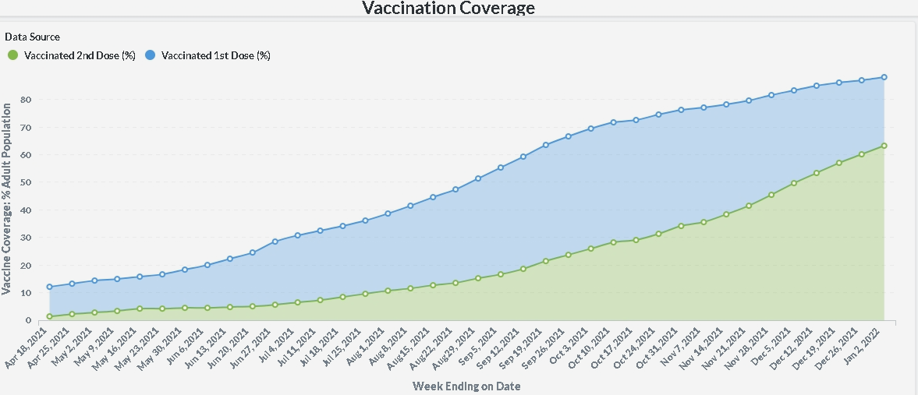

*Figure 1- Vaccination coverage( Partially vaccinated- 80% and Fully vaccinated- 60%)*

Coming to the current situation in India. As of end Jan 2022, 40,622,709 confirmed cases of COVID-19 with 492,327 deaths, reported to WHO. As of 24 January 2022, a total of 1,634,962,688 vaccine doses have been administered. According to the officials, 75% of India has received at least their first doses of vaccines.(see figure1).The Indian government has implemented a lockdown in 4 phases in the first wave(2020) and A lockdown in the second wave(2021). **In 2020***, the First Phase* **(25 March– 14 April)**, nearly all services and economic activities were suspended, except essential markets. *In the Second Phase* **(15 April – 3 May)**, lockdown areas were classified into "red zone", indicating the presence of infection hotspots, "orange zone" indicating some infection, and "green zone" with no infections. *In the Third Phase* **(4–17 May)** Government of India (GoI) further extended the lockdown period to two weeks beyond 4 May, with some relaxations.*In Fourth Phase* **(18–31 May)** Ministry of Home Affairs (MHA) extended the lockdown for a period for two weeks beyond 18 May, with additional relaxations. For any updates on COVID-19 pandemic public may refer to the official website (<https://www.mygov.in/covid-19/>) by Government Of India (GoI) .**In 2021,** February end 2021, India got hit by the largest COVID wave. It is cited that people started becoming careless, not wearing masks and not following social distancing, around November- April. This wave caused a rapid surge in cases and deaths

Currently the condition in India is still unstable, As the nation has been hit by the new variant of Covid-19 called “Omicron”. The cases have started flaring up since new years eve. In the month of jan 2022 the daily new reported cases are 312k (see figure 2).At this point, it is necessary to evaluate the Indian government’s responses and actions towards the COVID-19 outbreak. It is important to realize the effectiveness of the previous responses and **extend its applicability to the Omicron variant** as well. Additionally it also helps to identify which policy in-specific worked previously and how to reimplement them in such a way that they work in newer conditions also.

The purpose of this study was to assess the Indian government’s response (economic index, health & containment index, stringency index) to COVID-19 epidemic and investigate thoroughly **what policies could be reinforced for the Omicron variant**. Although vaccinations have been rendered in huge amounts yet there seems to be a surge in new cases, which could indicate that the vaccines cannot extend its performance beyond COVID-19. As new variants emerge, primary vaccines seem to be obsolete and less effective. It is important to focus on Non-Pharmaceutical Interventions (NPIs) policies to enhance herd immunity and restrain the spread. Hence, we will discuss in this paper what & how NPIs have worked in the past and how to leverage it to restrict new COVID-19/ Omicron infections.

Straight to the point, we take a time-series regression approach to measure the effect of government response on COVID-19 pandemic in India and use the **stepwise regression to identify the effect of each specific policy**.

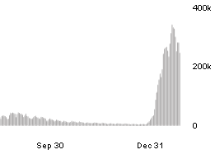

*Figure-2 Surge in new cases since late Dec 2021*

In brief, the number of new reported cases can be used to measure the acuteness of the outbreak, but it may be not suitable for regression analysis due to its volatile nature. Therefore, We use a more reliable way of estimating effective reproduction number Rt to measure the severity of the COVID-19 epidemic in India. Rt , which is a key concept in epidemiology, is defined as the average number of secondary cases produced by a primary case. Detailed explanation about the data of Rt will be given in Section 3.1

1. **Data collection**

In this paper, we are going to assess the Indian government’s policy measures and its direct impact on Covid19 outbreak. OxCGRT dataset ([GitHub - OxCGRT/covid-policy-tracker: Systematic dataset of Covid-19 policy, from Oxford University](https://github.com/OxCGRT/covid-policy-tracker)) to investigate the effects of various policy measures used by governments to mitigate the spread of COVID-19 and Rt is used for impact-analysis on Covid19.

OxCGRT tracks various Non-Pharmaceutical Intervention (NPI) policies and categorizes them into four categories, containment and closure policies(**C1-C8**), economic policies(**E1-E3**), health system policies(**H1-H8**), and miscellaneous policies(M1), and record these policies as policy indicators in the form of ordinal scale or U.S. dollars(refer Table 2). Economic policies are recorded as the actual spending. From 12 June 2021, vaccination policies were added to the OxCGRT dataset. In addition, OxCGRT summarizes these policies by providing 4 kinds of composite index, government response index, containment and health index, stringency index, and economic support index. Stringency index represents the stringency of various containment and closure policies. Containment and health index evaluate both health system policies and containment and closure policies. Among the 4 kinds of index, government response index is the most comprehensive. In addition to the various policies mentioned above, it also includes economic support policies.

A point to note here is that, Each of these indices report a number between 0 to 100 that reflects the level of the government's response along certain dimensions. This is a measure of how many of the relevant indicators a government has acted upon, and to what degree. However, The index cannot say whether a government's policy has been implemented effectively.

Table2 -OxCGRT index and policy indicator

| **Indicator ID** | **Indicator Name** | **Government Response Index** | **Containment and Health Index** | **Stringency Index** |
| --- | --- | --- | --- | --- |
| C1 | School closing |  |  |  |
| C2 | Working closing |  |  |  |
| C3 | Cancel public events |  |  |  |
| C4 | Restrictions on gatherings |  |  |  |
| C5 | Close Public Transport |  |  |  |
| C6 | Stay at home requirements |  |  |  |
| C7 | Restrictions on  internal movement |  |  |  |
| C8 | International travel controls |  |  |  |
| E1 | Income support for households |  | X | X |
| E2 | Debt/contract relief for households |  | X | X |
| E3 | Fiscal measures | X | X | X |
| E4 | International support | X | X | X |
| H1 | Public information campaigns |  |  |  |
| H2 | Testing policy |  |  | X |
| H3 | Contact tracing |  |  | X |
| H4 | Emergency investment in healthcare | X | X | X |
| H5 | Investment in vaccines | X | X | X |
| H6 | Facial Coverings |  |  | X |
| H7 | Vaccination Policy |  |  | X |
| H8 | Protection of elderly people |  |  | X |

We perform time-varying regression analysis between effective reproduction numbers and the OxCGRT indices. While the simple regression model can only estimate the average effect of the independent variable on the dependent variable within the sample period, the time-varying regression model is able to procure the real-time impact of this study. By weighting-in the coefficients that are changing over a period of time, we can make a more accurate estimation about the after-effects of the government response to COVID-19 epidemic. Following this step, we run a stepwise regression with time-varying coefficients on the policy indicators provided by OxCGRT to identify which specific policy is effective in controlling the spread of COVID-19 infections. The reason that we use stepwise regression is that, if we use all policy indicators as independent variables in one regression, multicollinearity in the data of policy indicators makes the regression unfeasible. We need to find the best combination of independent variables. Stepwise regression is a smart way to determine the best combination of regressors. Our empirical strategy is summarized in Figure 3.

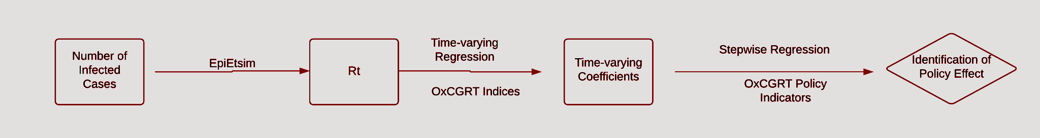

*Figure 3- .Empirical strategy*

A point to note is that, In this paper, we have used only NPI Indicators that have been used by the Government of India in their COVID19 response. However, there are several other countries to which this study may extend to. It completely depends on the inherent differences between countries and severeness of COVID conditions prevailing in that region. Having said that, our parametric regression model can be used to assess the effect of each specific policy taken by that government. Policy impact-analysis can help determine factors that could give an indication of a successful /unsuccessful national response to COVID-19. Along with that, an in-depth investigation of specific NPIs policies between different periods or regions will aid in future pandemic preparedness.

1. **Empirical Analysis**

3.1. Data

In our empirical analysis, the sample period is from 1 January 2020 to 28 January 2022. Figure 4 shows a few basic statistics of COVID-19 in India. The dataset has been taken from OurWorldInData Team([covid-19-data/owid-covid-data.csv at master · owid/covid-19-data · GitHub](https://github.com/owid/covid-19-data/blob/master/public/data/owid-covid-data.csv), accessed on 28 Jan 2022). You can refer to the full code [here](https://github.com/Suhaib-88/ResearchPaper-on-Assessing-Government-Response-to-Covid-19--DataAnalyze2021.git).

As we can confirm from these figures, there have been two periods (waves) when the infection rate has spiked tremendously. The peak of the first wave came in May 2020. Following the first wave, the peaks of the second wave were in May 2021. Looking at the daily new cases graph[ see figure 4], We can visibly see an alarming rate of growth in newly infected cases, By end Jan 2022.

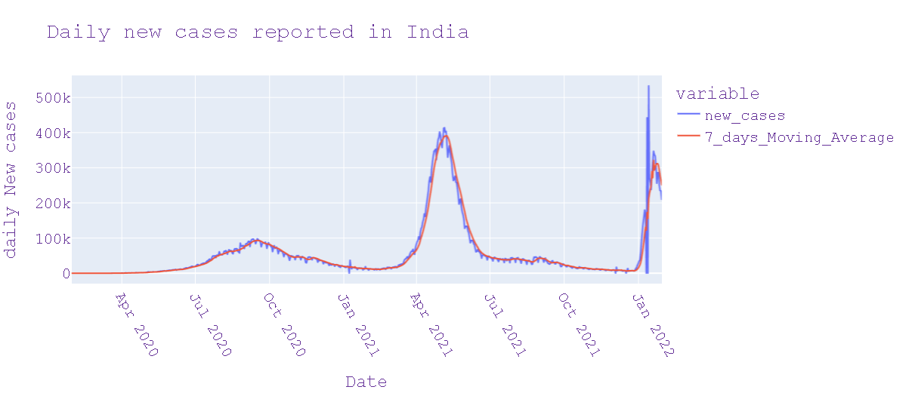

**(a) Number of Daily New Confirmed Infected Cases**

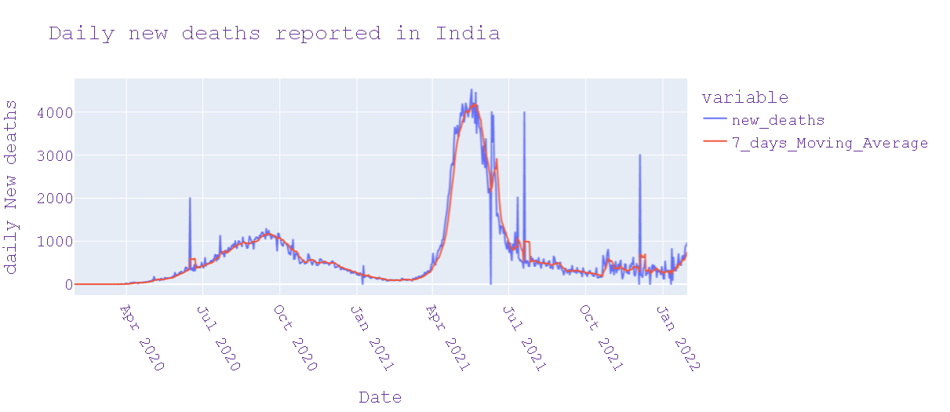

**(b) Number of Daily New Confirmed Death Cases**

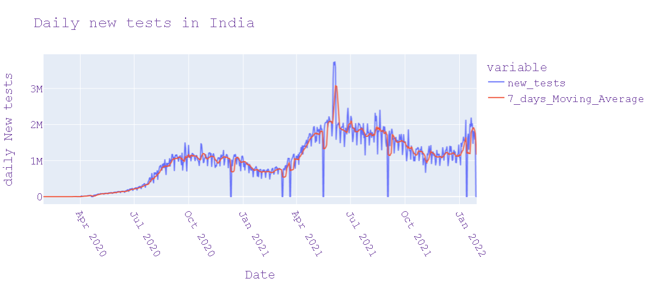

**(c) Number of Daily New Tests conducted**

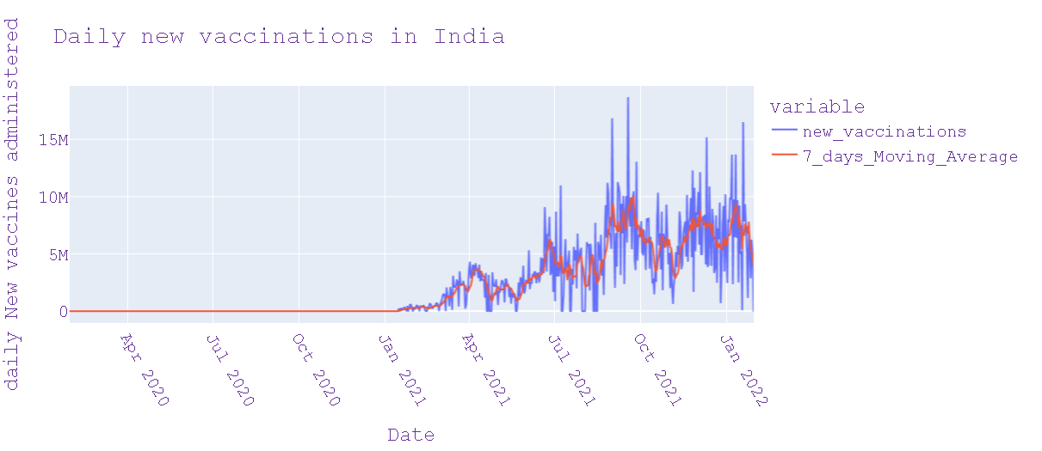

**(d) Number of Daily New Vaccinations administered**

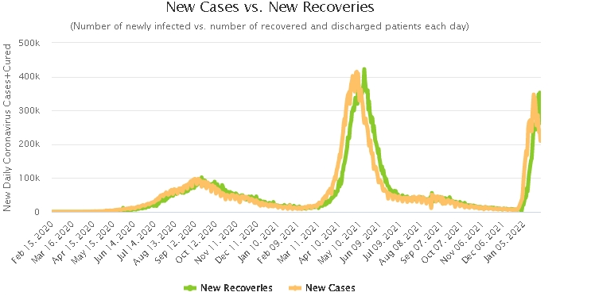

**(e) Number of daily New cases vs New recoveries**

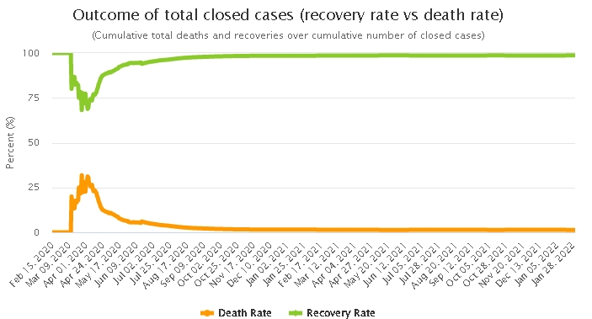

**(f) Cumulative Total Recovery Rate vs Death Rate**

*Figure 4 - Statistical Summary of COVID-19 pandemic in India*

As we introduced in Section 1, the main data used in empirical analysis are Rt,

policy indicators, and 3 kinds of index provided by OxCGRT. Each of these indices report a number between 0 to 100 that reflects the level of the government's response along certain dimensions. This is a measure of how many of the relevant indicators a government has acted upon, and to what degree. The index cannot say whether a government's policy has been implemented effectively. OxCGRT index is given in (see Figure 5). Each specific policy indicator is given in Figure 6.

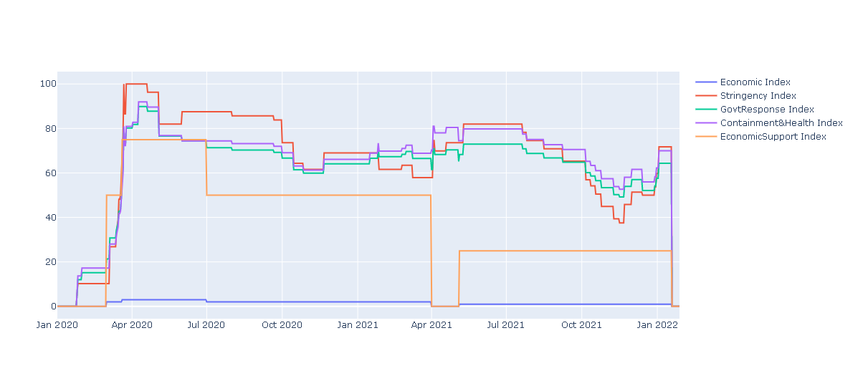

*Figure 5- OxCGRT index of Indian government*

|  |  |
| --- | --- |
|  |  |
|  |  |
|  |  |
|  |  |
|  |  |
|  |  |
|  |  |

*Figure 6- OxCGRT specific policy indicators implemented by Govt. Of India*

1. **Research Methodology**

4.1 Statistical testing

Table 2 summarizes the indices and policy indicators provided by OxCGRT. Index is calculated by aggregating corresponding policy indicators. For the details of calculation, please refer to the related Github page ([covid-policy-tracker/index_methodology.md at master · OxCGRT/covid-policy-tracker · GitHub](https://github.com/OxCGRT/covid-policy-tracker/blob/master/documentation/index_methodology.md), accessed on 28 Jan 2022).

We use Python package *EpiEstim* to estimate the Rt from Jan 2020 to Jan 2022. You can refer to the full code [here](https://github.com/Suhaib-88/ResearchPaper-on-Assessing-Government-Response-to-Covid-19--DataAnalyze2021.git). From Figure 7, It is clearly visible that 3 peaks of infection spread have occurred during the given period. The data of daily infected cases used in the estimation of Rt

is collected from the OurWorldinData Team([covid-19-data/owid-covid-data.csv at master · owid/covid-19-data · GitHub](https://github.com/owid/covid-19-data/blob/master/public/data/owid-covid-data.csv), accessed on 28 Jan 2022). When using EpiEstim, we must specify the serial interval (SI) of COVID-19 infection. Fitted the data of 18 infector-infectee pairs on a log-normal distribution of serial interval and obtained the mean and standard deviation of serial interval as 4.3 days (95% confidence interval: 3.2 days, 6.0 days) and 3.0 days (95% confidence interval: 1.9 days, 4.9 days) respectively.

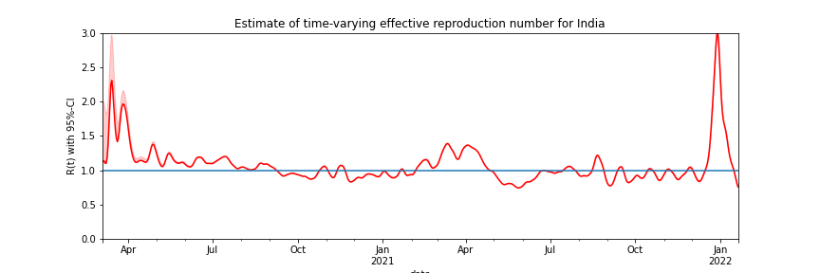

*Figure 7-* *Rt estimated by EpiEstim*

Now, we summarize the descriptive statistics of all data in Table 3. Using Augmented

Dickey–Fuller (ADF) unit root test. The more negative test statistics(see column 8, in Table 3), the more likely we are to reject the null hypothesis (we have a stationary dataset).

As part of the output, we look-up ADF statistic for **Rt** in table 3. Here,We can see that our statistical value of (-2.67) is less than the value of (-2.56) at 10%. This suggests that we can reject the null hypothesis with a significance level of 10%, which is quite high.

So the takeaway here is that, along with **Rt,** We failed to reject the null hypothesis that the dataset is stationary for OxCGRT indexes (Government Response Index, Stringency Index, Containment and Health Index) as well, indicating that the time series is non-stationary and does have a time-dependent structure.

*Table 3- Summary statistics*

| Variables | Sample Period | Obsv | Mean | Std Dev. | Min | Max | ADF Test t-Stats | ADF Test p-Value |
| --- | --- | --- | --- | --- | --- | --- | --- | --- |
| Rt estimated by EpiEstim | 4 march 2020 – 20 January 2022 | 688 | 1.12 | 0.30 | 0.77 | 4.37 | -2.67 | 0.078 |
| Government Response Index | 1 January 2020 – 28 January 2022 | 759 | 61.32 | 19.64 | 0.0 | 89.84 | -1.92 | 0.31 |
| Stringency Index | 1 January 2020 – 28 January 2022 | 759 | 65.27 | 24.35 | 0 | 100 | -2.61 | 0.08 |
| Containment and Health Index | 1 January 2020 – 28 January 2022 | 759 | 64.65 | 20.65 | 0 | 91.96 | -1.99 | 0.28 |

**\*Test critical values of ADF test are :**'1%' : -3.43, '5%' : -2.86, '10%' : -2.56

4.2 Regression Analysis

We use a simple log-log specification for time-varying regression. εt represents the disturbance term in regression equations.

log Rt = β0,t + β1,t log Index t + εt . –(1)

Index t represents the index series of OxCGRT. β0,t is the time-varying constant and β1,t is the time-varying coefficient. Index t measures the effect of log Index t on log Rt , which can be explained as 1% change of Index t can generate β1,t% change of Rt . Generally, β1,t < 0 means that the government response can mitigate the spread of epidemic by reducing Rt . Note that, since the data series of Rt is high series-correlated. Our aim here is not to find a time-series model that can fit Rt well, but to find the statistical significance between Rt and Index t . When we treat β0,t and β1,t as fixed coefficients, we can obtain the values of coefficients by running an OLS regression. Results of OLS regression are given in Table 4.

Given the negative value of coefficient on Index t with 1% statistical significance, although regressions with government response measured by different indices and Rt have small difference in the size of coefficients, it can be confirmed that the government response does have effect on reducing Rt , which means that government response does reduce and slow down spread of the COVID-19 epidemic. In table 4, For instance, for every 1% change in Rt, we get -0.0069 % change in **Government Response Index.**

*Tab**le 4- OLS regression*

|  | **Government Response Index** | **Containment and Health Index** | **Stringency Index** |
| --- | --- | --- | --- |
| **Coef (x)** | -0.0069 | -0.0077 | -0.0030 |
| **Std Error for coef** | 0.001 | 0.001 | 0.001 |
| **Constant** | 1.56 | 1.65 | 1.32 |
| **Std Error for Constant** | 0.054 | 0.053 | 0.042 |

In Table 4, Coefficients are computed for each OxCGRT Indexes, along with their constants. And every Non-Pharmaceutical-Intervention (NPI) policy is helping reduce COVID-19 spread during that particular period. However, we also want to determine if government policies change overtime or not. Thus, we re-estimate this regression equation in a time-varying context.

In table 5, for instance, the deterrent effect of the 2nd Wave(20 March 2021–28 Aug 2021) is clearly stronger than the effect of the 1st Wave(7 April 2020–25 August 2020). However, measures taken in the Second wave were far less effective than the First wave. Table 5, summarizes the average effect of the emergency state on COVID-19 epidemic in India. For example, in case of Containment and Health Index the average effects have gone from

-0.0090 in First Wave to +0.0014 in Second Wave, indicating that the policies had no impact in reducing Reproduction number (Rt).

*Table 5- OLS regression*

|  | **Stringency Index** | **Government Response Index** | **Containment and Health Index** |
| --- | --- | --- | --- |
| **First Wave** | -0.0070 | -0.0087 | -0.0090 |
| **Second Wave** | -0.0006 | -0.0018 | 0.0014 |

In Figure 8, β1,t coefficient values of OxCGRT Indexes are illustrated, given the sample period.The dark gray-shaded area indicates a sharp rise in COVID-19 cases and light gray-shaded area indicates the government's response to it. Pointing to the fact that, the Indian government is imposing lockdowns only after a large wave of newly reported cases. The Red line shows the average level above which the government implements restriction measures to limit outspread.

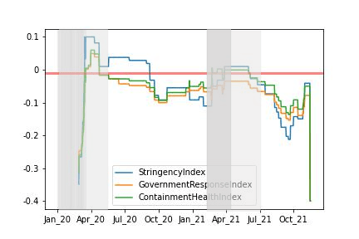

*Figure 8- Time-varying coefficient β1,t using Flexible Least Square method (FLS)*

Now after calculating β1,t , we use it as a dependent variable in a new regression equation to obtain specific policy indicators. ∑i Indicator i,t denotes a set of policy indicators. For instance, In order to get the regression of Rt on the government response index we calibrate β1,t in time-varying context. Then finally, we put all 16 policy indicators that are aggregated in government response index into the ∑i Indicator i,t. However we will witness the existence of multicollinearity between policy indicators. To solve this problem, we use stepwise regression to choose the best subset of 16 policy indicators. If γi is negative and statistically significant, the corresponding policy indicator can be identified as an effective measure to control epidemic.

β1,t = γ0 + γi ∑ i Indicator i,t + εt —(2)

Each table from table number :4–8 gives the results of variable selection and corresponding regression. Point to remember here is that policy indicators with statistically significant coefficients have negative signs attached and thus can be said to be “an effective policy measure”. From the derived results, we can conclude that not all policies may be effective in controlling the COVID-19 epidemic in India.

*Table 6. Stepwise regression of policy indicators in government response index.*

| **Variable** | **Coefficient** | **Standard Error** | **p-Value** |
| --- | --- | --- | --- |
| **Constant** | -0.220 | 0.004 | 0.000 |
| **C1** | -0.0755 | 0.003 | 0.000 |
| **C3** | -0.1548 | 0.004 | 0.000 |
| **C5** | -0.0839 | 0.004 | 0.000 |
| **C6** | -0.1133 | 0.004 | 0.000 |
| **C7** | -0.0856 | 0.005 | 0.000 |
| **C8** | -0.0939 | 0.002 | 0.000 |
| **H2** | -0.0773 | 0.005 | 0.000 |
| **H3** | 0.0226 | 0.007 | 0.001 |
| **H6** | -0.0488 | 0.003 | 0.000 |
| **H7** | 0.0018 | 0.002 | 0.259 |
| **H8** | -0.0864 | 0.004 | 0.000 |
| **E1** | -0.1143 | 0.009 | 0.000 |
| **E2** | -0.0571 | 0.005 | 0.000 |

From the regression results in Table 6, the most impactful measures are: C3 (cancel public events) and C6 (Stay at home requirements). However, H3 (contact tracing) is noted to be a statistically significant indicator denoting no impact in reducing Rt. We can even say that lack of H3 (contact tracing) can lead to an increase in unreported covid cases.Additionally, E1 (income support for households) and E2 (debt/contract relief for households) are effective policies. As economic support provided by the government was quite promising. As the Finance Minister of India Smt. Nirmala Sitharaman announces a relief package of Rs 6,28,993 crore to support the Indian economy in the fight against COVID-19 pandemic. With an additional Rs 1.1 lakh crore loan guarantee scheme for COVID affected sectors. (For details about all OxCGRT policy indicators refer to table 2 )

*Table 7. Stepwise regression of policy indicators in containment and health index*

| **Variable** | **Coefficient** | **Standard Error** | **p-Value** |
| --- | --- | --- | --- |
| **Constant** | -0.087 | 0.004 | 0.000 |
| **C1** | -0.3503 | 0.002 | 0.000 |
| **C2** | -0.1005 | 0.002 | 0.000 |
| **C3** | -0.1679 | 0.005 | 0.000 |
| **C4** | -0.0848 | 0.004 | 0.000 |
| **C5** | -0.0919 | 0.003 | 0.000 |
| **C6** | -0.1379 | 0.003 | 0.000 |
| **C8** | -0.1011 | 0.002 | 0.000 |
| **H2** | -0.0945 | 0.006 | 0.000 |
| **H3** | 0.0418 | 0.008 | 0.000 |
| **H6** | -0.0629 | 0.003 | 0.000 |
| **H7** | -0.0050 | 0.002 | 0.008 |
| **H8** | -0.1141 | 0.005 | 0.000 |

From the regression results In table 7, the most impactful policies are: C1( school closing), C3 (cancel public events) and C6 (stay at home requirements).Additionally, H7 ( vaccination policy) is a statistically significant measure to reduce reproduction number (Rt). However, Even here we can say that lack of H3 (contact tracing) can lead to an increase in unreported covid cases. As a specific example, C3 (Cancel of public events) is quite effective because India is a socialistic society and very frequently conducts cultural festivals & events where mass gatherings are quite common, so risk of transmissions also increase.

*Table 8. Stepwise regression of policy indicators in stringency index.*

| **Variable** | **Coefficient** | **Standard Error** | **p-Value** |
| --- | --- | --- | --- |
| **Constant** | -0.095 | 0.002 | 0.000 |
| **C1** | -0.0517 | 0.001 | 0.000 |
| **C2** | -0.0594 | 0.001 | 0.000 |
| **C3** | -0.1004 | 0.002 | 0.000 |
| **C5** | -0.0637 | 0.002 | 0.000 |
| **C6** | -0.0586 | 0.003 | 0.000 |
| **C7** | -0.0581 | 0.003 | 0.000 |
| **C8** | -0.0619 | 0.001 | 0.000 |

From the regression results showed in Table 8, we can find that containment policies,

C3 (cancel public events) ,C5 (close public transport), C6 (stay at home requirements), and C8 (International travel controls), are still the most effective methods to control the spread of the COVID-19 epidemic. Particularly, C3 (cancel public events) and C6 (stay at home requirements) are two policies having the most impact on all indexes. Adding to it, during Covid-19 all major cultural and religious events were suspended, and people were restricted to their homes which led to lesser risk of transmissions. Note that, although we have differences among different regressions, we can summarize the common conclusion from these results. Containment policies are the most effective methods to control the COVID-19 epidemic in India.

1. **Discussion of Empirical Results**

Through our evidence-based analysis, we can deduce that the Indian government’s response on COVID-19 epidemic is quite effective. However, there are many policy measures that cannot be reimplemented for the third wave of Omicron-variant.

Pin-pointing on a single policy failure, from tables: 7 -8, we can clearly see H3 (contact tracing) being statistically significant in its ineffectiveness of policy implementation.Even Though on April 2, 2020, India introduced its COVID-19 contact tracing app, **Aarogya Setu**. It also helps citizens identify and mitigate their risk of getting infected from COVID-19. It's designed to keep a person informed in case he/she happens to cross paths or come in close contact with someone who is COVID-positive. The app tracks such developments through a blue-tooth and location-generated social graph, which shows up an alert message in case anyone in the vicinity is tested positive. Even Though India's Covid-19 national guidelines say states should [**trace contacts of at least 80% of positive cases within 72 hours**](https://pib.gov.in/PressReleasePage.aspx?PRID=1637024). Many states report its numbers for primary and secondary contact tracing have fallen since September 2020. As India's parliamentary committee on health and family welfare has said that "poor contact tracing and less testing could have been a factor for the exponential growth of Covid".

Illustrated in figure 6, we can see a surge in cases above its levels, 3 different times during the period. Demonstrating that the strategy adopted by Government of India is not helping to reduce COVID-19 below a certain level, proving the *mild effectiveness of policies*. Currently, knowing that India is on the verge of a third wave it is time to look for more effective strategies to control the epidemic based on the current laws and administrative system. However, we should note that the conclusion must be explained in the context of the socio-political and health situation in India.

Recent research shows that the spread of COVID-19 can be affected by many other factors. Ref. [1] ’s analysis shows that geographical and climatic factors, such as temperature, humidity, and latitude measurements, are consistent with the behavior of a seasonal respiratory virus. Ref. [2] also confirms the seasonality in the spread of COVID-19. A further important variable is characterized by the chronic exposure of the population to atmospheric contamination which can affect the severity and spread of the virus.Refs. [3–5] are typical works related to this topic. It is necessary to consider these factors when we evaluate the government performance of fighting COVID-19.

Based on the results of this study, a comprehensive review of the past research, the following three recommendations are offered as urgent priorities for Government Response to COVID-19 in India. Firstly, focus on getting the entire population of India fully vaccinated, because there is a high dropout rate from 2nd dose of vaccine, So measures should be taken to ensure people get fully vaccinated, before moving to Non-Pharmaceutical Interventions (NPIs). Secondly, as found in this paper comprehensive contact tracing is a problem, lack of contact tracing is directly related with increase in unreported cases, so more work in that direction is needed(refer table 6). Finally, India needs to incentivise & boost economic activity to further increase its expenditure in the healthcare sector and not collapse at the time of adversity.

1. **Concluding Remarks**

In this paper, we compute the effective reproduction number Rt of the COVID-19

epidemic to measure the severity of the current situation. In addition, we use the OxCGRT to measure the government response on COVID-19 epidemic. Our research objective was to decipher the effect of the Indian government’s response on COVID-19 epidemic.

The main methodology is regression analysis with Rt and OxCGRT, including indices

and policy indicators. We confirmed the average effect by OLS regression, which means

that, on the whole, the Indian government’s response to the epidemic is effective in

slowing the infection rates. However, through time-varying regression we were able to tell that the Government of India was unprepared for the Second Wave. As cases spiked out of proportion (416k cases/day), many policies were deemed to be inefficient except containment and closure policy measures. Using the FLS method, results showed that the effect is changing over time, specifically, demanding a more tactical response. Finally, stepwise regression identifies the effect of specific policy. At the time of submission, the third emergency state is looking more apparent, with the rise in Omicron cases. In table 5, the **Government Response Index** has seen the most impact in Wave I and Wave II. Therefore specific policies that fall under it may be quite effective in fighting the new variant as well (refer table 6).

The time-varying regression visualizes the effect of government response

on COVID-19 in a consistent and comparable way, but this method is not suitable for comparison between different countries or regions. Apparently, elections of the Prime Minister of India are going to be held in 2023, so it is necessary to execute more effective strategies to control the spread of virus during elections as well as pre-election rallies. Again, we have to note that the empirical results and related policy implications should be explained in the context of the statistical models proposed in this paper**.**

Data Availability Statement: Publicly available datasets were analyzed in this study. This data can be found here: <https://github.com/OxCGRT/covid-policy-tracker> and <https://github.com/owid/covid-19-data/blob/master/public/data/owid-covid-data.csv>.

Code Availability Statement: The entire code used to generate all figures and tables was written in Python language and can be found here: <https://github.com/Suhaib-88/ResearchPaper-on-Assessing-Government-Response-to-Covid-19--DataAnalyze2021.git>

References

1. Sajadi, M.M.; Habibzadeh, P.; Vintzileos, A.; Shokouhi, S.; Miralles-Wilhelm, F.; Amoroso, A. Temperature, Humidity, and Latitude Analysis to Estimate Potential Spread and Seasonality of Coronavirus Disease 2019 (COVID-19). JAMA Netw. Open 2020,3, e2011834. [[CrossRef](http://dx.doi.org/10.1001/jamanetworkopen.2020.11834)]

1. De Natale, G.; De Natale, L.; Troise, C.; Marchitelli, V.; Coviello, A.; Holmberg, K.G.; Somma, R. The Evolution of COVID-19 in Italy after the Spring of 2020: An Unpredicted Summer Respite Followed by A Second Wave. Int. J. Environ. Res. Public Health 2020, 17, 8708. [[CrossRef](http://dx.doi.org/10.3390/ijerph17238708)] [[PubMed](http://www.ncbi.nlm.nih.gov/pubmed/33255181)]

1. Fattorini, D.; Regoli, F. Role of the Chronic Air Pollution Levels in The Covid-19 Outbreak Risk in Italy. Environ. Pollut. 2020, 264, 114732. [[CrossRef](http://dx.doi.org/10.1016/j.envpol.2020.114732)] [[PubMed](http://www.ncbi.nlm.nih.gov/pubmed/32387671)]
2. Conticini, E.; Frediani, B.; Caro, D. Can Atmospheric Pollution be Considered A Cofactor in Extremely High Levels of SARS-CoV-2 Lethality in Northern Italy? Environ. Pollut. 2020, 261, 114465. [[CrossRef](http://dx.doi.org/10.1016/j.envpol.2020.114465)] [[PubMed](http://www.ncbi.nlm.nih.gov/pubmed/32268945)]

1. Domingo, J.L.; Rovira, J. Effects of Air Pollutants on The Transmission and Severity of Respiratory Viral Infections. Environ. Res.2020, 187, 109650. [[CrossRef](http://dx.doi.org/10.1016/j.envres.2020.109650)] [[PubMed](http://www.ncbi.nlm.nih.gov/pubmed/32416357)]